**IPCONFIG** – Displays basic IP configuration details of the system.

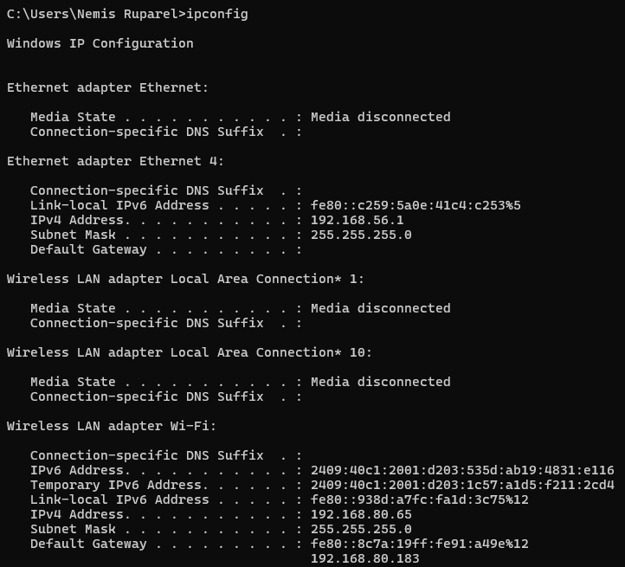

**Ipconfig/all :**  displays detailed network configuration information for all network adapters on a Windows system.

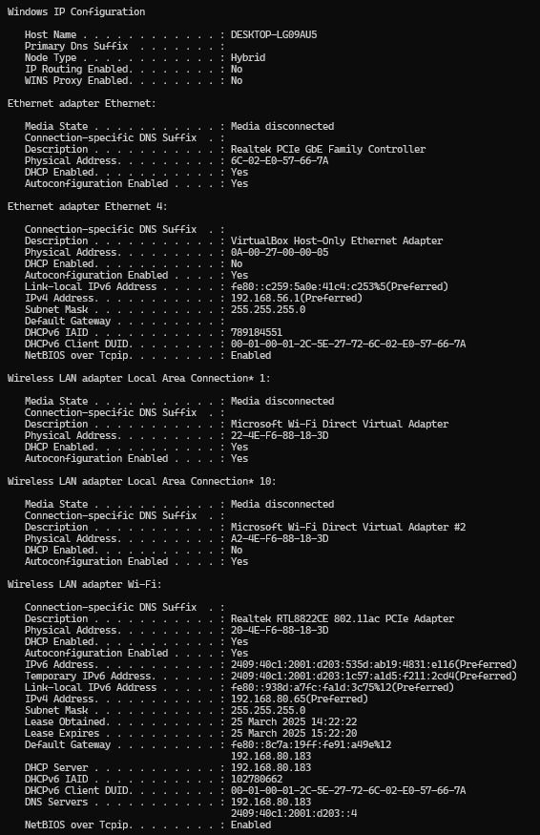

**Ping** – Sends ICMP packets to test network connectivity and response time.

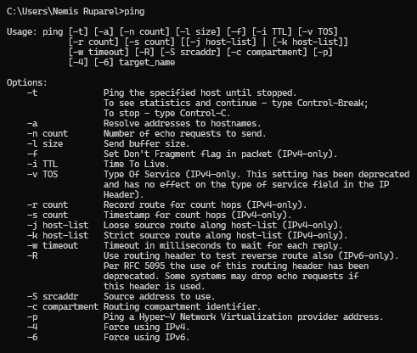

**ping -t** [**www.google.com**](http://www.google.com) – Continuously pings Google until manually stopped.

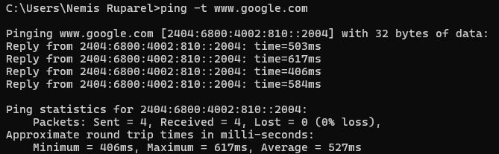

**Tracert** – Traces the route packets take to a destination, showing each hop.

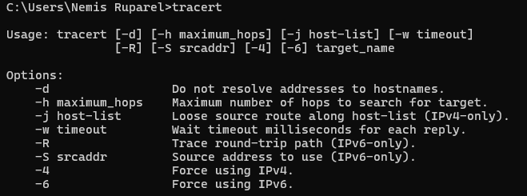

**tracert -h 5** [**www.google.com**](http://www.google.com) – Traces the route to Google, limiting to 5 hops.

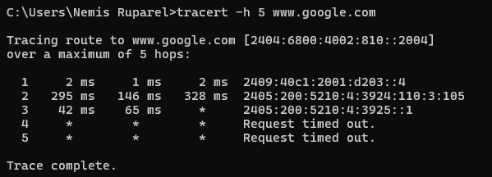

**Pathping** – Combines Ping and Tracert to analyze network latency and packet loss.

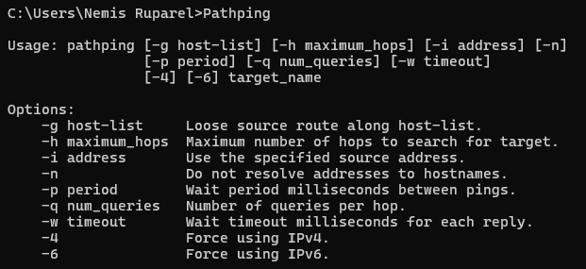

**Netstat** – Displays active network connections and listening ports.

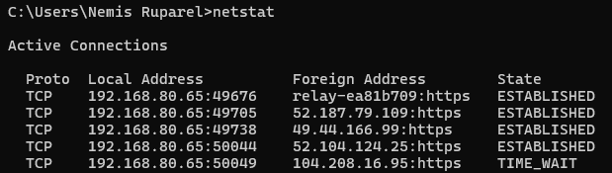

**Netstat -n** – Shows active connections with numerical IP addresses instead of names.

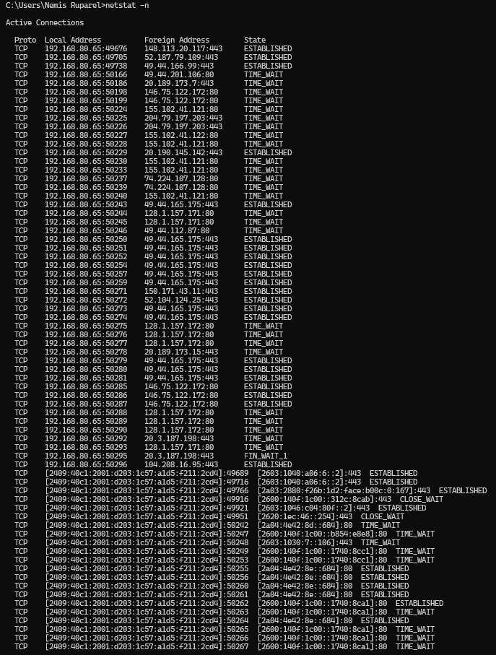

**Netstat -a** – Lists all active and listening ports, including TCP and UDP.

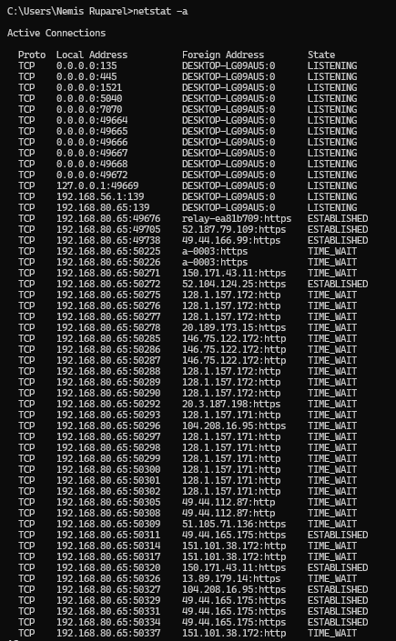

**Route** – Displays or modifies the system’s routing table.

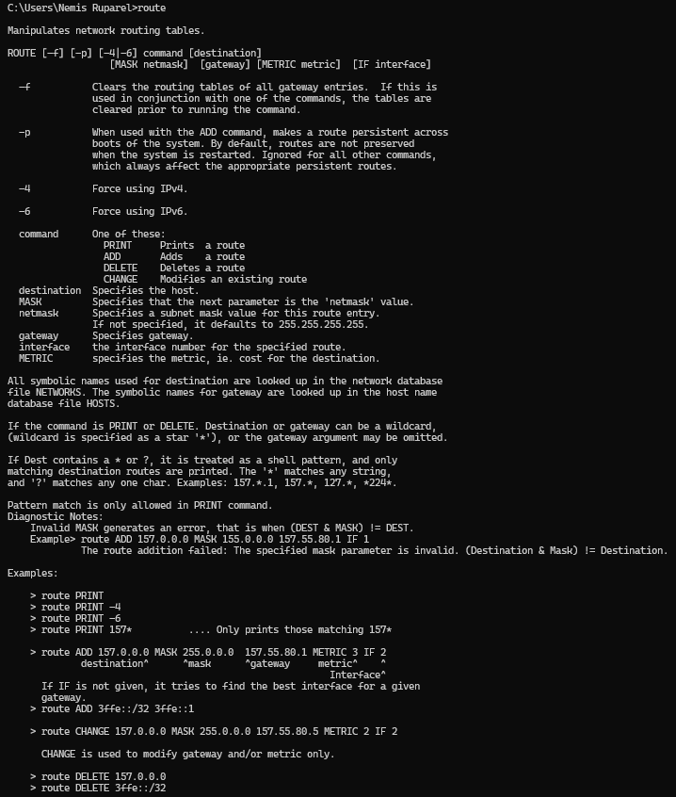

**Route -4** [**www.google.com**](http://www.google.com) – Shows IPv4 route details to Google.

